Social Work Assistant
Program

Student Handbook
2012-2013

Social Work Assistant Program



TABLE OF CONTENTS
Student Handbook
2025-2026

Section I - Introduction Page No.
A Message from the Program Director 1
Welcome 2
Purpose 2
Faculty and Administration 3
Confidentiality 3
Scope of Practice 4-7
Code of Ethics of Social Work Professionals 8-15

Section II - Academic Expectations
Academic Expectations 17
Admission Criteria/Student Selection Procedures 18
Intended Student Outcomes 19
Tuition and Fees 19
Attendance Policy 19-20
Missed Assignments, Tests, Presentations 20
Cheating 20
Fingerprinting 20-21
Field Trips 21
Access to Records 21-22
Evaluation of Student Performance 22-23
Personal Appearance 24
Course of Study/Curriculum Guide 25-26
Course Descriptions 27-28

Section III - Practicum Expectations
Practicum Overview 30-31
General Behavior and Professional Ethics 31-33
Responsibilities of Practicum Site 34
Responsibilities of Student 35
Responsibilities of Practicum Instructor 36
Agreements Between the College and Practicum Site Supervisors 37
Practicum’s Can be a Mutually Enriching Experience 37
Training Plan/Learning Goals and Objectives 38
Weekly Notes 38
Practicum Site Evaluations 38

Section IV - Miscellaneous
Social Work Assistant Club 40
Social Work Program Advisory Board 40
Signature Page 41-42
Written Interview 43

SECTION I
INTRODUCTION

Dear Social Work Assistant Students:

Welcome to Zane State College’s Social Work Assistant Program! I am honored to serve as the Program Director. You are entering an exciting and challenging program that will change your life and the lives of others. I am eager to meet you and assist you in this wonderful journey!

The information included in this handbook will assist you in answering questions, explaining processes, and familiarizing you with the high standards and expectations. As you read through this handbook, please note any questions you have.

Whether you know exactly what path you plan to take in this broad field, or if you are just beginning to explore your options, I am here to assist you. Our program offers you the opportunity to work with many of our community partners who often employ our graduates. Our Social Work Club provides you an amazing chance to network and learn about the programs and services in our community. Please contact me at (740)588-1286 or e-mail me @ scurtis@zanestate.edu, so we can develop your success plan.

Respectfully,

Stacie Curtis



WELCOME

Welcome to the Zane State College Social Work Assistant Program (SWKA). This handbook has been designed to provide you with the necessary information specifically related to the SWKA program about policies, procedures, and the expectations of the students enrolled in the program. It will serve as a guide through the many aspects of your college career from admission into the program to graduation.

This handbook should not be considered a statement of all policies of Zane State College. Additional information can be found on the Home Page under Academic Catalog online. Read the following information carefully and feel free to contact the Program Director with any questions.

PURPOSE

The Social Work Assistant Program at Zane State College prepares individuals for employment as an entry-level professional in agencies and organizations which provide human or social services. The Generalist approach to practice is taught which involves the problem-solving process to assess, plan, and intervene with challenges confronting individuals, families, groups, and communities.

Social Work professionals are committed to the enhancement of human well-being and alleviation of poverty and oppression.

The program seeks to achieve the following two goals: (a) training for employment and/or
(b) providing core course work that may transfer to four-year educational programs which lead to a four-year bachelor degree in Social Work.

Graduates, under supervision, will be able to provide intake/social assessments and referrals, crisis intervention and resolution, case management and outreach, facilitation of groups, and education and prevention services.

Course work follows the Council for Social Work Education guidelines and includes classes in human behavior, social welfare policy, ethics, cultural diversity, interviewing, and assessment of human needs. Students will gain hands-on experience by completing fieldwork in a social service agency during their second year in the program.

Upon completion of the associate degree program graduates will be eligible for registration with the Ohio Counselor and Social Work Board as a Social Work Assistant (SWA) (Application found at this web address http://cswmft.ohio.gov/) and with Ohio Chemical Dependency Board as a Chemical Dependency Counselor Assistant (CDCA) or Registered Applicant for Ohio Prevention Specialist credential (Application found at this web address http://ocpd.ohio.gov/).

SOCIAL WORK ASSISTANT PROGRAM
FACULTY AND ADMINISTRATION

Division of Health & Public Service

Stacie Curtis, MSW, CYC-P
Program Director, Assistant Professor
(740) 588-1286
Office: Health Science Hall, Room 325F

Duane Stutzman
Interim Division Dean
(740) 588-1315
Office: Health Science Hall, Room 325C

FACULTY/STUDENT CONFIDENTIALITY POLICY

There are several exceptions to student/instructor confidentiality. Included are cases involving intent to harm others, situations where people are a danger to themselves, legal proceedings that subpoena records, and allegations of abuse. The state of Ohio requires professionals to report instances of known or suspected abuse against children and the elderly.

Additionally, regarding professional ethics, Social Work educators have an ethical responsibility to not engage in any dual or multiple relationships with students in which there is a risk of possible exploitation or potential harm to the students. (NASW, 2015)

References:
http://www.socialworkers.org/pubs/Code/code.asp
National Association of Social Workers, (2015) Code of Ethics. Washington D.C.
National Organizations of Social Work Educators (NOHSE) Code of Ethics

SECTION II
Scope of Practice
NASW Code of Ethics
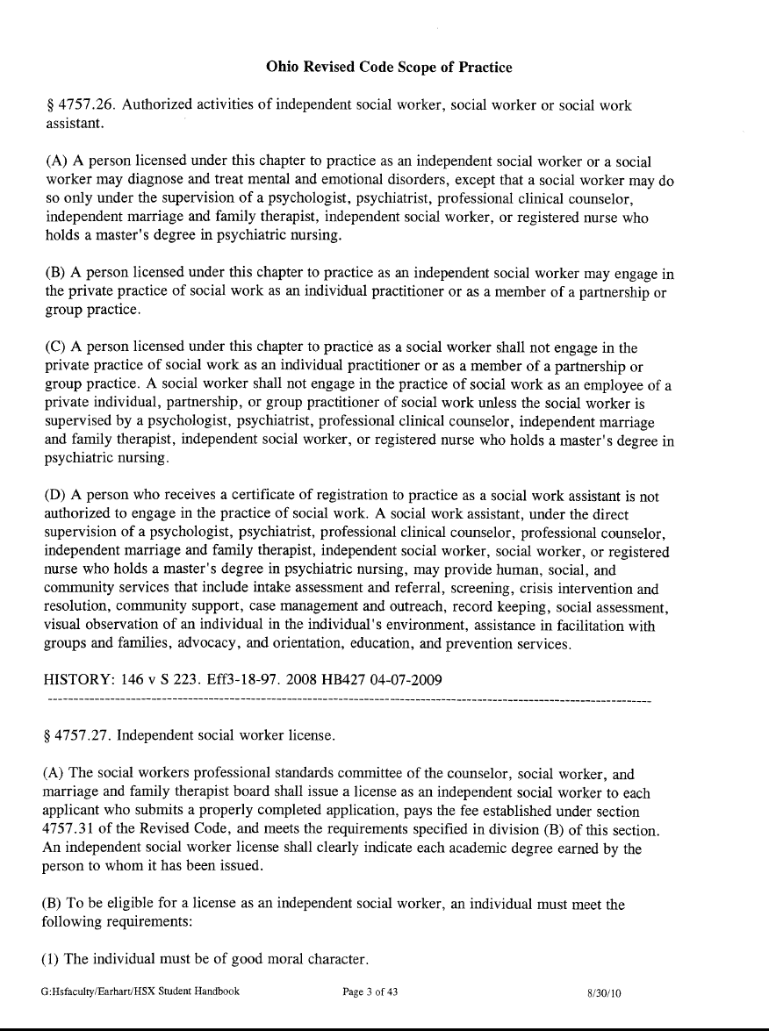
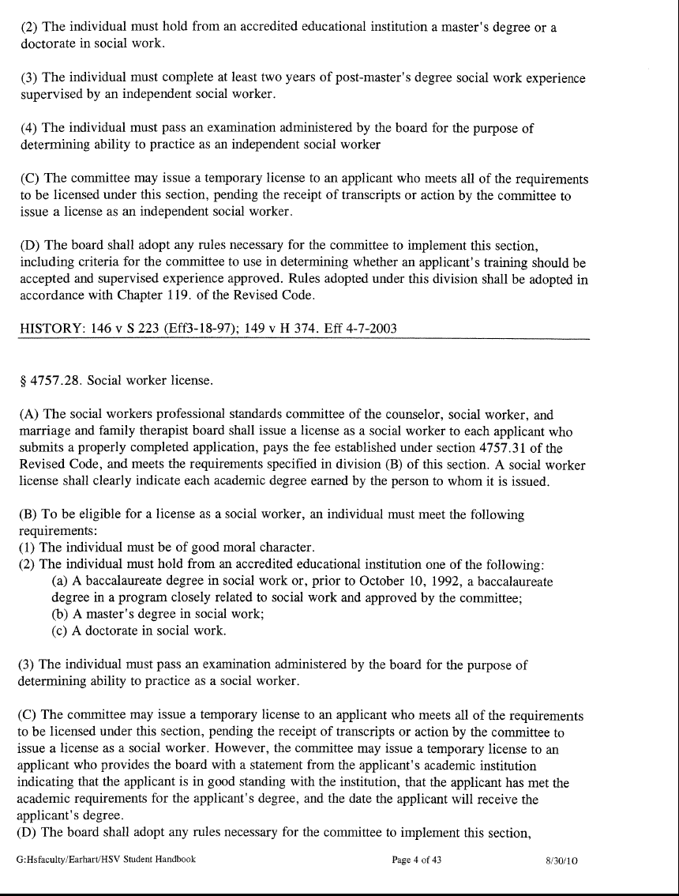
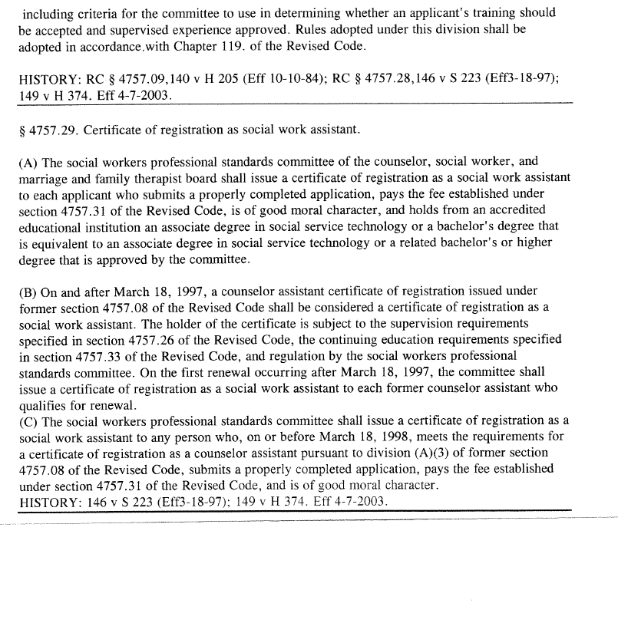
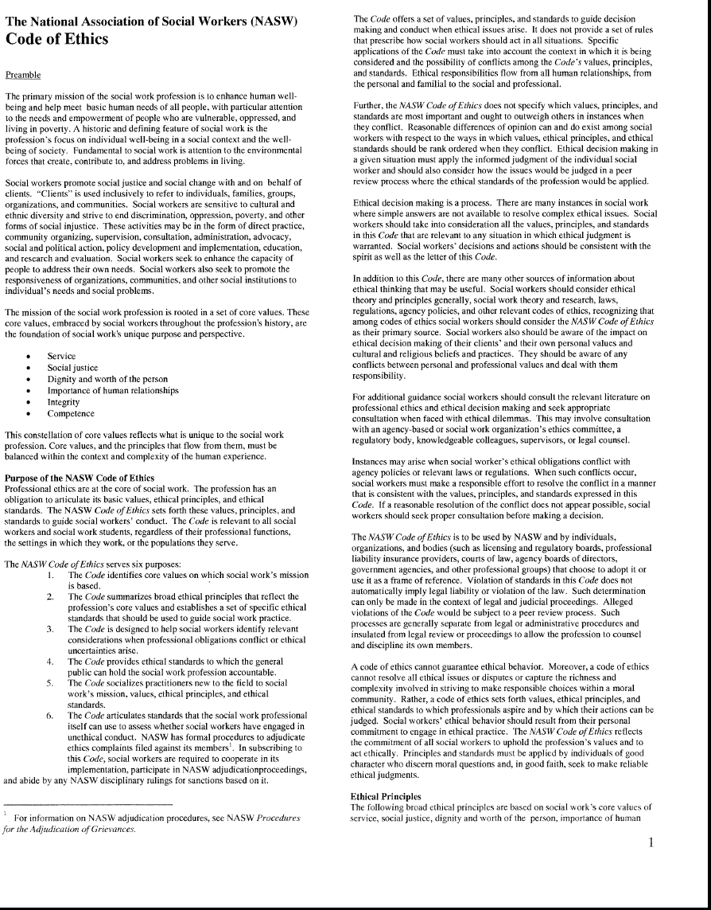

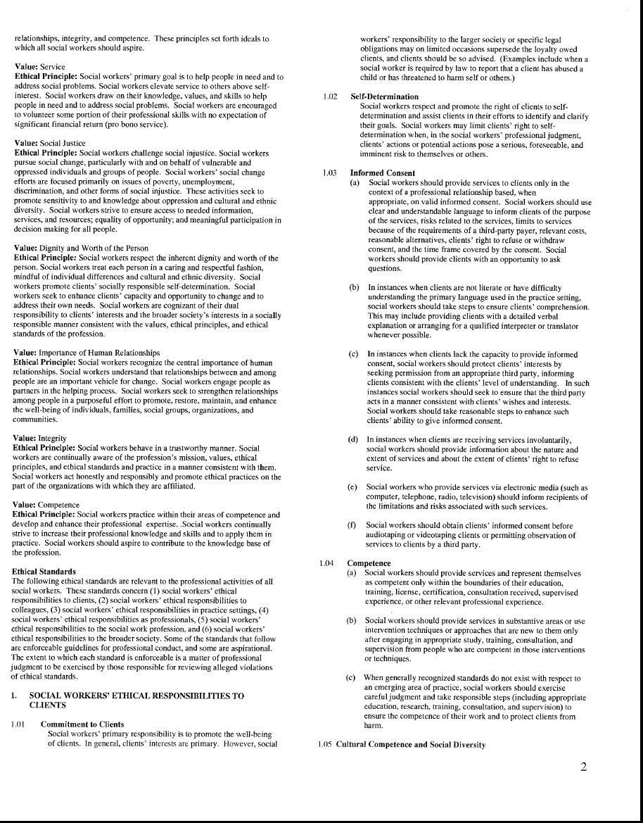

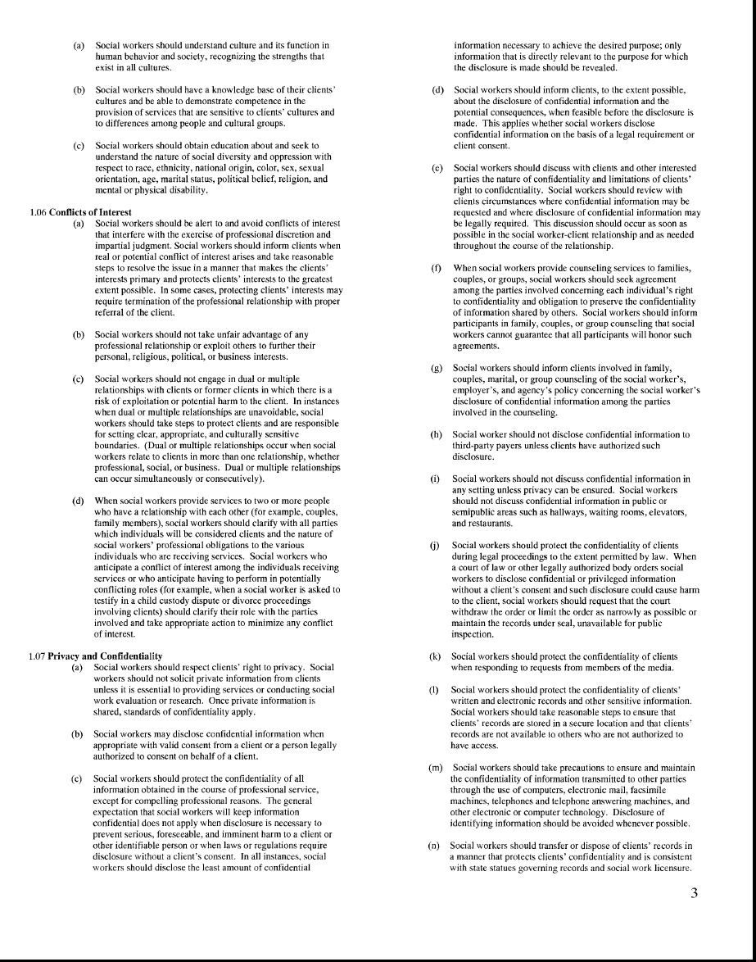

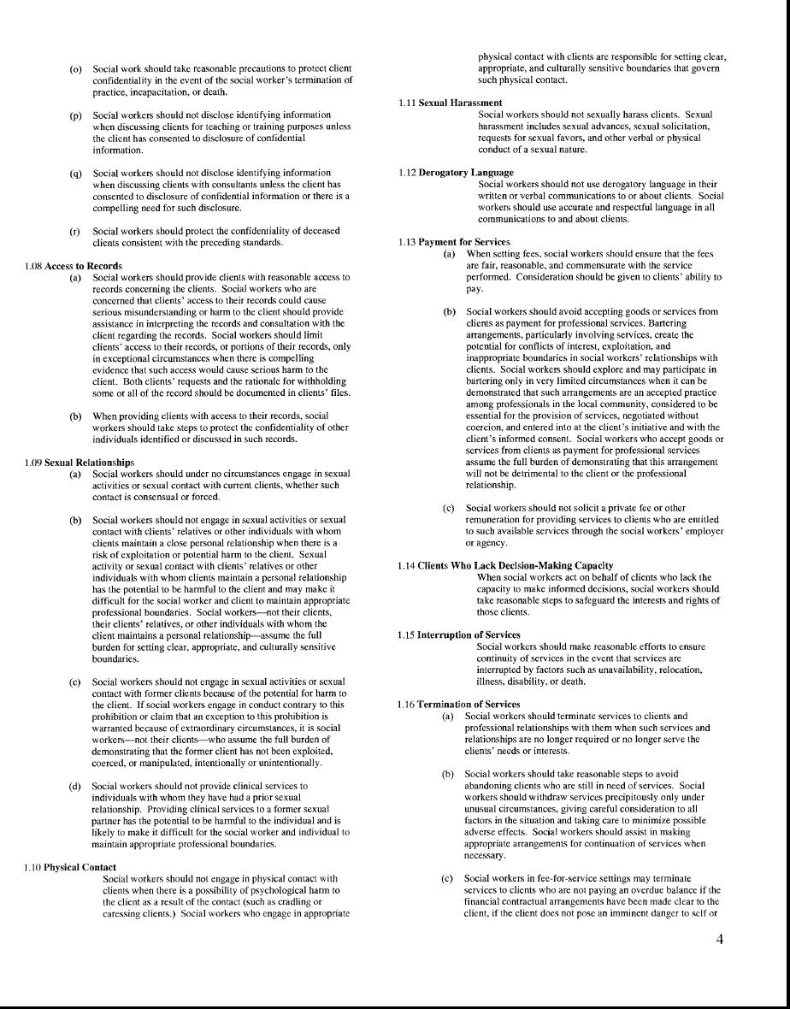

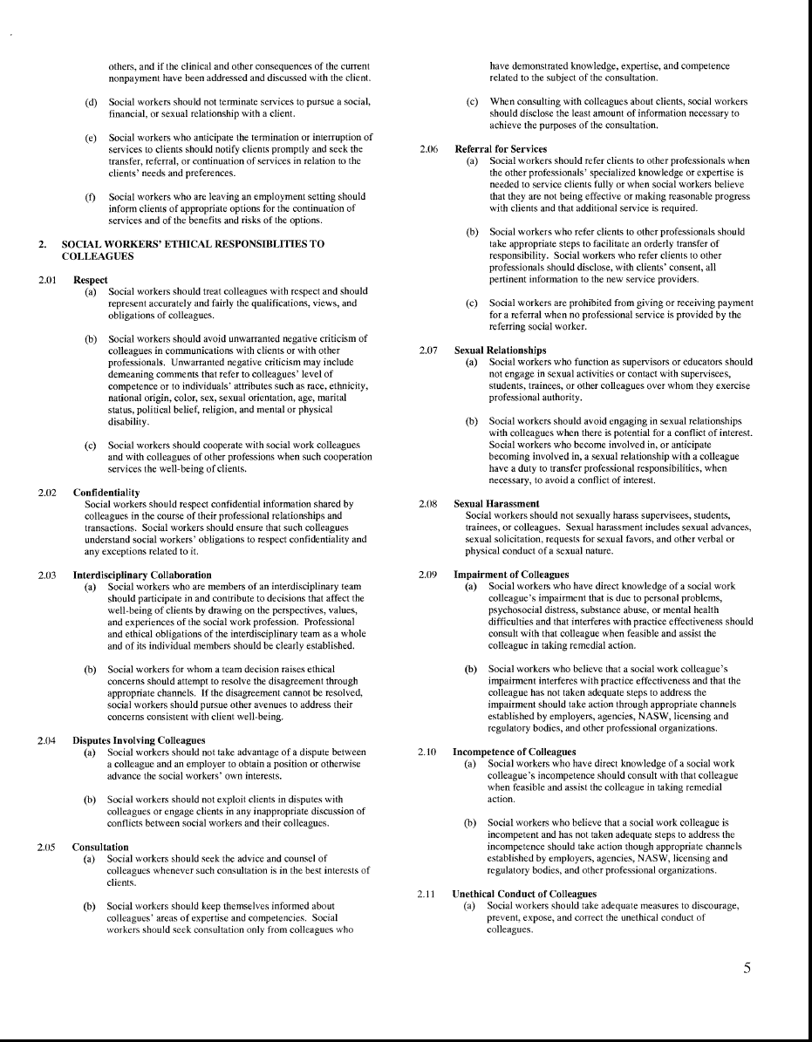

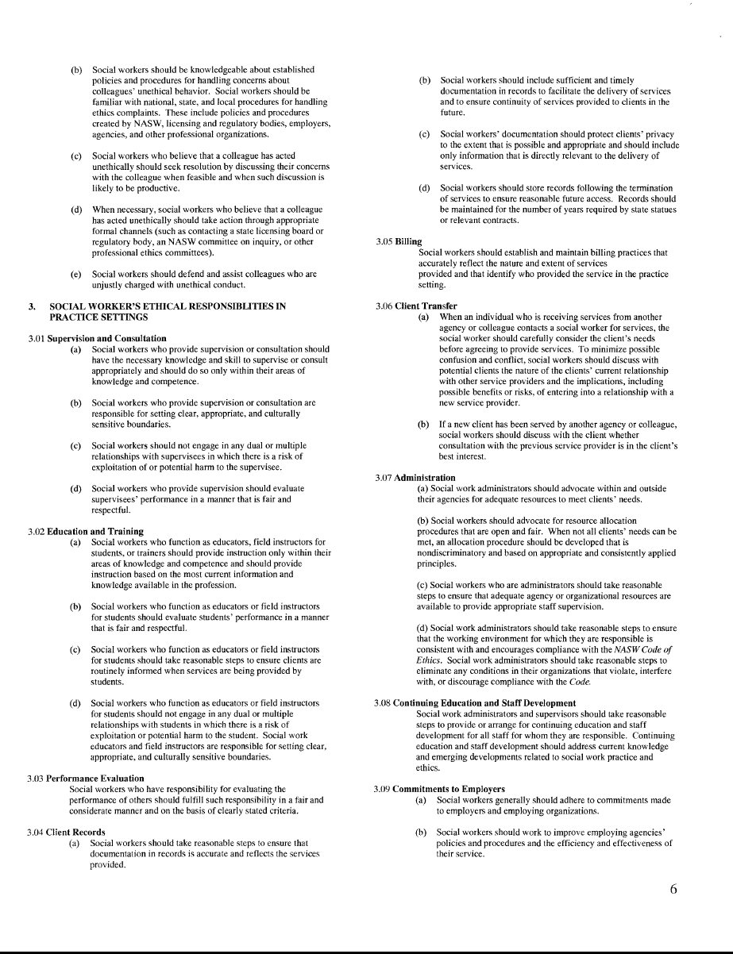

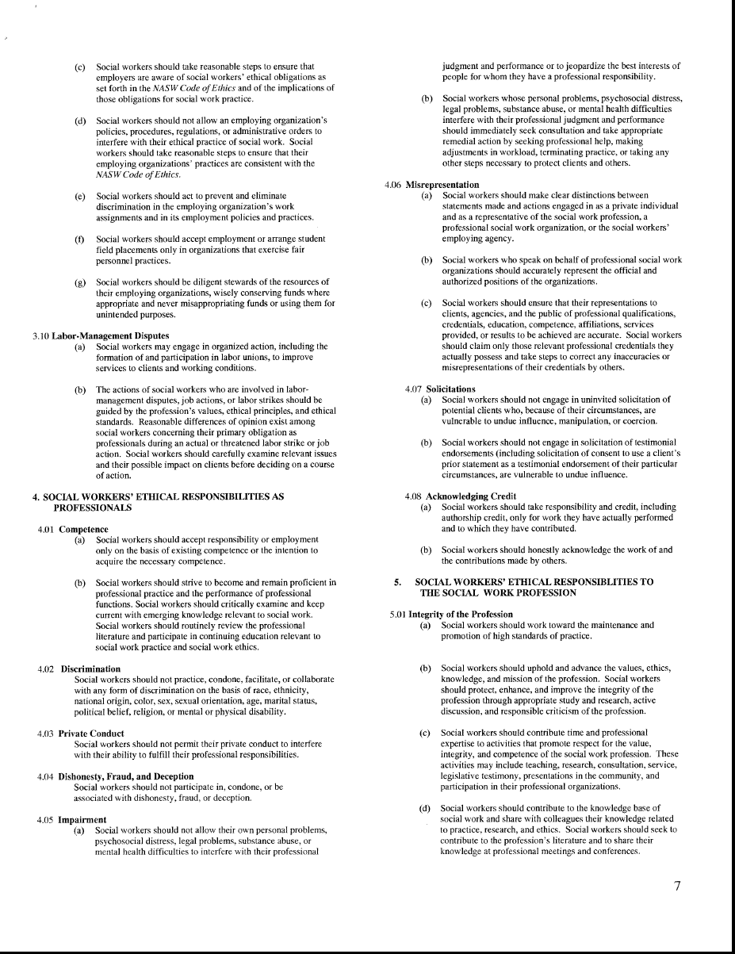

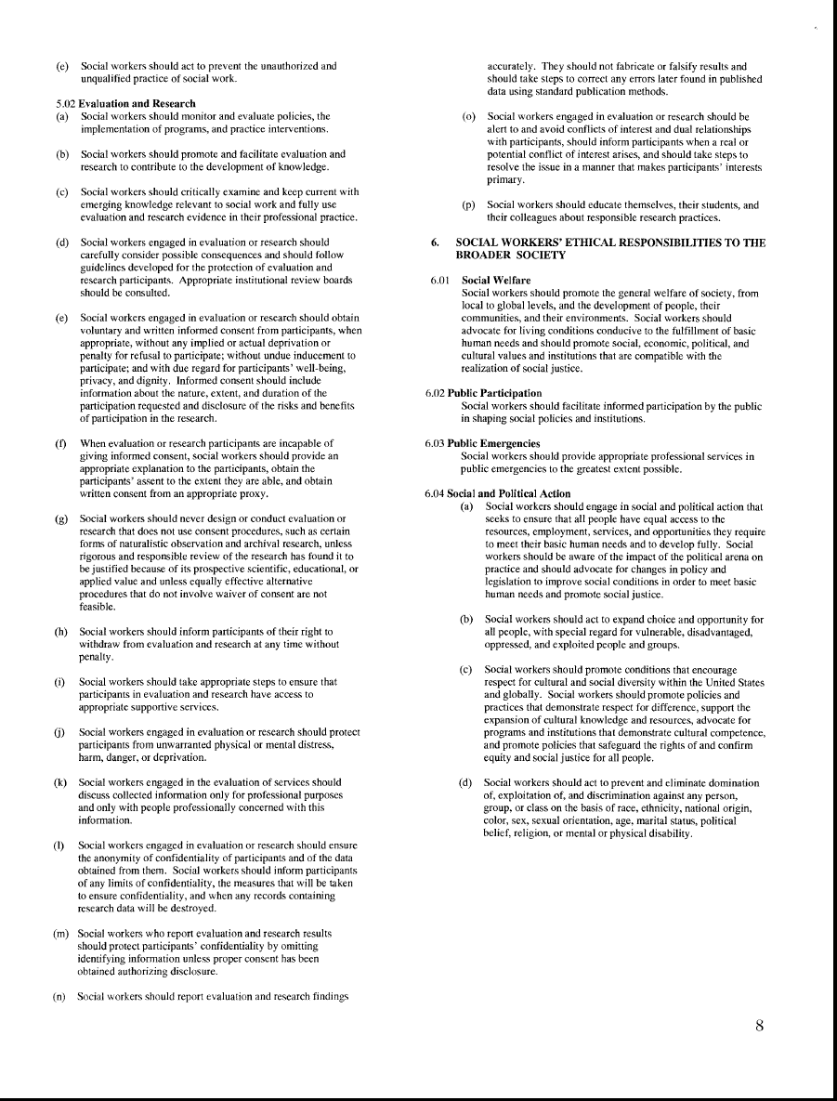

SECTION II
ACADEMIC EXPECTATIONS

Academic Expectations

In compliance with Ohio Senate Bill 38 (effective October 9, 1993) the results of a completed criminal background/records investigation will be required prior to enrollment in SWKA 2300 & other courses due to the coursework. If a student has a criminal conviction, the student should directly contact the Ohio Counselor, Social Worker, and Marriage and Family Therapist Board (https://cswmft.ohio.gov/get-licensed/licensing-resources/Disqualification_from_Licensure_Due_to_Criminal%20_Conviction) &/or the Ohio Chemical Dependency Counselor Board (https://ocdp.ohio.gov/Contact) to discuss their conviction(s) and any disqualifications for licensure. Students whose records indicate convictions for crimes which would keep them from having contact with children or older adults (by the Ohio Revised Code) will receive advisement and re-direction as appropriate.

The academic and fieldwork requirements of the program are rigorous and require commitment from the student. Students in the SWKA Program are expected to maintain an overall GPA of at least 2.0 and to obtain grades of C or higher in all technical courses to progress in the program.

No student or potential student will be denied acceptance into the program due to disability, age, race, color, sexual orientation, religion, national origin, or ancestry.

Social Work professionals need to possess a large repertoire of skills and abilities due to the diversity in practice or work settings. Physical characteristics necessary to carry out the major tasks of a particular job depend on the setting: however, Social Work professionals should generally have the physical capacity to communicate effectively, both orally and in writing; to protect clients and self from aggressive behavior; to recognize the overt signs of distress in others; and to respond to others in a supportive manner.

Any student or potential student who has need for special or adaptive equipment should confirm arrangements through Student Services at least 30 days prior to registration each semester.

Students transferring from another college will follow the same admission procedure. To transfer credit for courses taken at another institution, an official transcript will be reviewed by the Registrar and a decision will be made based on the following criteria:
- Courses must be similar in content and credit values to those they replace.
- The student must have earned a C or higher in the course to transfer.

Social Work Assistant Program
Admission Criteria/Student Selection Procedures

The following list of application materials/forms MUST be presented to the Social Work Program Director in a three-pronged folder (not three ringed binder). Put your name, address, and student ID# on the front of the folder.
• Include and complete this checklist as the first page of your application folder.
• All items need to be placed in numbered page protectors.

□ | Page 1 | This page/checklist
□ | Page 2 | Signed Statements (see page 42 & 43 of this handbook). Sign the statement in four places indicating you have read and understand: 1) Ohio Law (ORC 3701-60-06), 2) the Curricular Sequence Statement, 3) Confidentiality and HIPPA, 4) Understanding of SWKA Policies and Guidelines.
□ | Page 3 | Written Interview (see page 44 of this handbook).

.

Social Work Assistant Program
Statements of Intended Student Outcomes

1. Demonstrate ethical and professional behavior in diverse human service settings.
2. Apply culturally responsive, strength-based approaches to service planning and delivery.
3. Implement evidence-based methods for assessment, intervention, and documentation.
4. Communicate effectively in written, oral, and digital formats with diverse audiences.
5. Use critical thinking to identify needs, solve problems, and make informed decisions using reliable knowledge and reasoning.
6. Promote social justice through advocacy, policy practice, and community engagement.

TUITION AND FEES

Information regarding current tuition and fee amounts is available in the Admissions Office. The student may also be responsible for purchasing miscellaneous supplies as required by individual courses. The Financial Aid Office will work with any student needing assistance with College fees.

ATTENDANCE POLICY

A significant portion of the educational process in Social Work is the development of a strong sense of responsibility on the part of each student toward fellow students, faculty members, and the social service agencies during the student practicum. One of the primary manifestations of this responsibility is regular, punctual attendance in the classroom and practicum site. Since it is recognized that absence is occasionally unavoidable, the following policy has been established for both the classroom and clinical areas:

Absences need to be reported to the instructor. A message may be left on the office voice mail or cell phone as indicated by the instructor or an e-mail may be sent notifying an instructor of your absence. The clinical instructor at the practicum site must also be notified by telephone prior to the beginning of the student’s assigned clinical time. Any work missed must be made up to the satisfaction of the instructor. It is the student’s responsibility to obtain any handouts or assignments given during the absence.

The instructor has the authority to give a written warning and reduce the course grade for absences if the pattern of non-attendance is consistent in nature from one semester to the next.

Bereavement, jury duty, military duty, and medical emergencies will be handled on an individual basis. Documentation may be required in some instances.

Inclement weather absence will be handled in accordance with the Zane State College inclement weather policy. Tardiness due to inclement weather will be handled on an individual basis. The use of common sense is highly encouraged in relation to inclement weather. The student should not put themselves in danger in order to attend their practicum assignment.

Excessive absenteeism and/or tardiness may result in dismissal from the program.

MISSED ASSIGNMENTS, TESTS, PRESENTATIONS

If a student misses a class where he or she is to present a project or when a test is scheduled, the student needs to make immediate arrangements to make up the test or reschedule the presentation if permitted by the instructor. Arrangements should be made prior to missed class whenever possible. Except in extreme cases, the test must be made up before the next class meeting of the course. If the test is not completed before the next class meeting, the test may not be taken and no credit will be granted. If an extreme circumstance prevents a test from being taken before the next session, specific arrangements must be made by the student with the instructor. If the presentation is one that can be rescheduled, this should be done during the next available class meeting. If the presentation cannot be made up, due to class scheduling, the student must make specific arrangements with the instructor to either present individually, or to do a written version of the presentation according to the instructor’s guidelines. Unfortunately, due to numbers of students and scheduling of classes, absence may limit the student from obtaining full credit for missed presentations. It is at the discretion of each instructor if late assignments are accepted at all. Please refer to the syllabus of each course in regards to your instructor’s policy.

CHEATING

Cheating of any form, including plagiarism, will not be tolerated in the classroom or practicum site. Instances of academic dishonesty will be grounds for a failing grade in that course or courses and possible probation or dismissal from the program or College.

A more detailed listing of further academic policies and regulations is contained in the Zane State College Catalog which is available on the Home Page online.

FINGERPRINTING

In accordance with Ohio Senate Bill #38, effective October 1, 1993, anyone having contact with children in a licensed day care or child care environment must undergo a criminal background investigation which includes fingerprint records being checked through the Bureau of Criminal Investigation. Likewise, the Ohio Revised Code, Section 3701-13, mandates that anyone providing direct care to an older adult on or after January 27, 1997, must have a criminal records background check.

Therefore, SWKA students are required by Zane State College to have this background investigation through fingerprints. Fingerprinting will be required by the faculty prior to placement in a field practicum.

Fingerprinting will be done through the Campus Bookstore or a local law enforcement agency if the student prefers, or requested by the practicum site.
Most of the agencies that accept students for practicum classes require the background check and may ask for the student to follow their own procedure. Likewise, several agencies will not accept students with felony backgrounds and/or certain misdemeanors (Please see page 47 of the Student Handbook for a list of the prohibited offenses). If two agencies refuse a student based on their background check it is then the Program Director’s choice as to whether or not to further pursue placement or to not place the student in a practicum site, thereby making them ineligible to complete the requirements for graduation from the Social Work Assistant program. The student’s advisor will then work with them to help develop an alternative educational plan.

FIELD TRIPS/COMMUNITY COLLABORATION

Field trips and community collaboration are a unique aspect of our program and serves as actual experience and observation of social work. Attendance and participation is considered the same as for the classroom. Students must provide their own transportation as they do to and from the College unless other arrangements are made.

ACCESS TO RECORDS

In compliance with the Buckley Amendment to the Family Educational Rights and Privacy Act of 1974, the following policy is established to provide proper procedure for access to student SWKA records:

Students must request inspection of their file by written request and will be granted access within 14 days of receipt of the written request to the SWKA Program Director. The student’s file must be inspected in the Program Director’s office and in the presence of the Program Director, or her designee, during normal business hours, or by special arrangement.

No records can be sent to any institution without the written consent of the student with the following exceptions:

* Transmittal of personal information to state and local government authorities as required by state statute.

* Release of directory information including the student’s name, address, major field of study, place of birth, participation in official recognized activities, dates of attendance, degrees and awards received, and the most recent previous educational institution attended.

The written consent to release records must specify the exact records to be released and to whom the records shall be released. A copy of these records will be given to the student, if requested. This includes the following information:

*Course transcript *Program evaluations *Other specified information *Degree Audit

Proper procedure for release of a student’s record involves the following considerations:

* Upon student request, a transcript will be sent to the authorized agency.
* Information may be sent out in compliance with a judicial order.

EVALUATION OF STUDENT PERFORMANCE

Student performance is evaluated in SWKA courses through the following: written objective and/or essay quizzes and tests; projects and presentations; classroom exercises; lab performance; and clinical performance. Several evaluation methods are used. These methods assist students in demonstrating strengths and allow faculty to provide feedback on areas needing improvement. Evaluation methods for each course are determined by the course content and objectives. SWKA faculty strive to pace and schedule evaluations throughout the semester so that daily/weekly learning is reinforced but such that the students can reasonably manage the work. In most courses a major evaluative assignment is required at or by midterm with other major course assignments following. If you have concerns about your academic achievement based on these evaluations, please notify the instructor as soon as possible. Your grades should be reflected in the Grade Center of Blackboard. You may request a meeting with your instructor, so he or she can offer appropriate guidance or assistance. If there is significant concern following midterm as to whether a student will successfully pass a course, the student should schedule a meeting with the instructor to develop a plan to help remedy the situation. The plan should be documented and both the student and instructor should obtain a copy of the plan.

Many SWKA courses are prerequisites for the following semester’s SWKA course work. If a student is unable to successfully complete an SWKA course(s), the student in most cases may not continue with further SWKA courses until successful completion of that course(s). An exception may occur if the student needs to take an incomplete grade for a course; if this occurs the student may possibly begin the next SWKA course, but will be required to complete the needed previous course work early in the semester. Students who are unable to successfully complete SWKA course work are generally advised to pursue an alternate program. In some circumstances, students may be given the option to repeat SWKA courses. A student can only be given two opportunities to earn a C in any SWKA courses. After the second failed opportunity the student will be dismissed from the program. Students are required to maintain a grade of C or above in technical courses.

If a student does not successfully pass any SWKA courses with a “C” or better during any one semester, PRIOR to retaking the course, the student must meet with the Program Director or designee to complete a success plan. The success plan will address the concerns relevant to the semester in which the student did not pass the course and will address other potential obstacles/barriers which may impact the student’s success. The success plan will be placed in the student’s file. The student must comply with all elements of the success plan to remain in the course(s) and be eligible to earn a passing grade. Failure to do so will result in the student failing the courses. A student is only permitted to retake any SWKA course one time. At the discretion of the Program Director with the input form the SWKA Advisory Board, a student may be provided an exception due to extenuating circumstances.

Returning students who previously failed multiple SWKA courses prior to the handbook change MUST complete a success plan with the Program Director or designee PRIOR to the end of the first week of the semester, or the student will not be permitted to continue in the course. The student will then only have 1 chance to retake ANY failed SWKA courses. If the student does not successfully pass any one of the previously failed SWKA courses, the student is ineligible to continue in the program.

Verbal and written communication is essential in the field of Social Work. APA documentation is required in our program. You can find assistance in My ZSC.

PERSONAL APPEARANCE

A specific dress code is not needed for most classroom or lab activities at the College. However, since students will be role playing and working in close contact with each other and making presentations during class, appropriate grooming and hygiene are encouraged as these will be in the group's best interest and will establish habits necessary for clinical practice in the future. During presentations students are expected to dress professionally. During clinical experiences, students will be required to follow the general dress code at the facility. In most cases this will consist of wearing informal slack outfits and/or dresses/ skirts, sturdy, comfortable shoes and socks or hosiery. Jeans and flip flops are unacceptable in the practicum placement. Overly loose- or tight-fitting clothes, mismatched, torn or stained clothing is not acceptable. A name badge may be required in some settings. In addition to the appropriate dress, care should be taken to make sure that hair is clean and styled, mustaches and beards are trimmed; nails are clean and trimmed or filed. In some health facilities you are not allowed to have acrylic nails.

Although cleanliness and neatness are essential, this does not imply that new or expensive clothes need to be purchased or that excess money needs to be spent on hair styling, etc.! This area is being emphasized to assist you to be attentive to your role as a professional and the importance of your appearance in relating to clients and co-workers. This includes minimizing or covering distinctive body piercings and tattoos as required by the agencies that take practicum students. Some agencies also will not accept students who smoke.

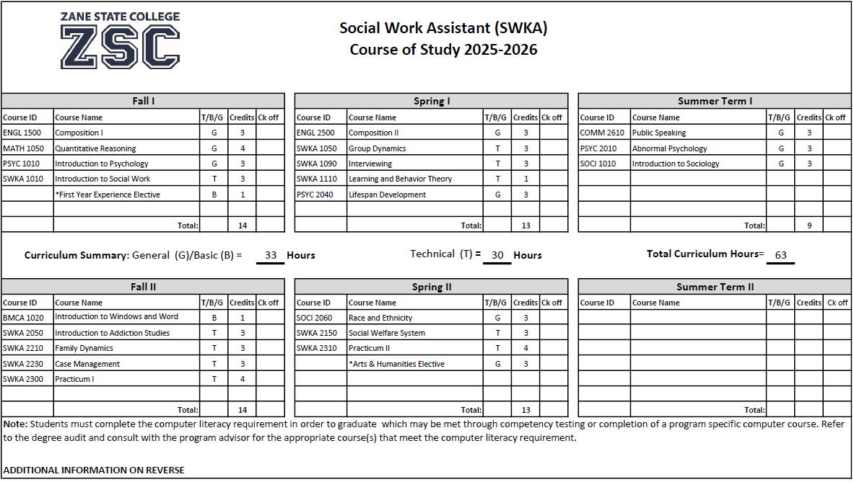

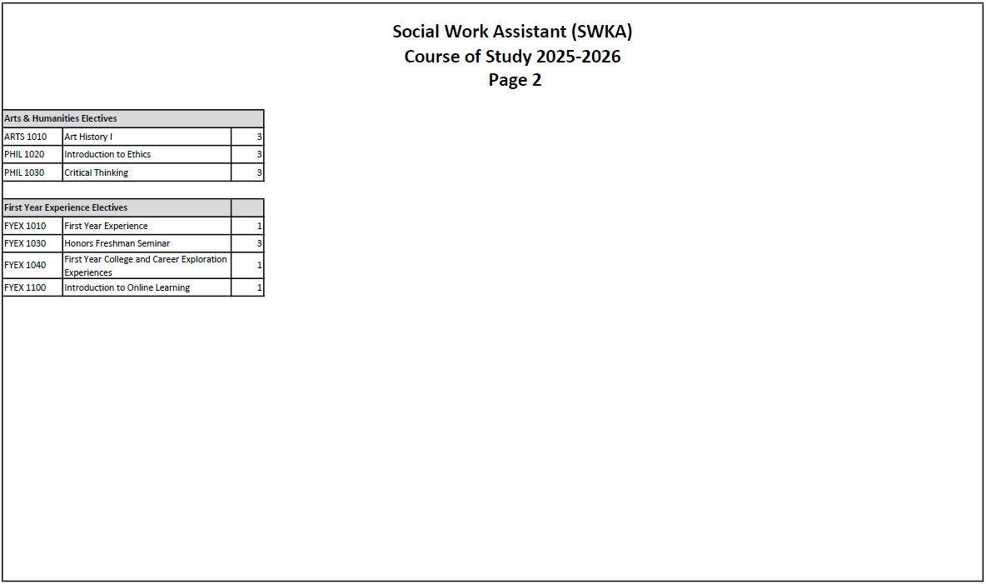

Course Descriptions

SWKA 1010- Introduction to Social Work- (3 credit hours-3 lecture –0 lab-T) Overview of the knowledge, values, and skills necessary for providing direct services to diverse populations. Students will also be exposed to the NASW Code of Ethics, standards for culturally competent practice, and organizational structures of practice settings.

SWKA 1050-Group Dynamics-(3 credit hours-2 lecture-3lab-T) Theoretical knowledge and practical experiences to prepare students for understanding the dynamics of group behavior. Course includes learning how to facilitate various forms of groups, how to develop treatment plans, and how to conduct recreational, diversional, and educational activities for those with mental illness, intellectual disabilities, and older adults.

SWKA 1090-Interviewing-(3credit hours-3 lecure-0 lab-T) Introduction to the theory and practice of structuring an interview using various techniques for questioning including Motivational Interviewing. Practical experiences include gathering, analyzing, and synthesizing information.

SWKA 1110-Learning and Behavior Theory-(1 credit hours-1 lecture- 0 lab-T) Study of the principles of learning and behavior as they relate to the process of developing behavioral change interventions including understanding the features of behavior modification. This course will include the areas of application for behavior modification, measurement of behavior and behavior change, basic principles of behavior, and how to establish new behaviors.

SWKA 2050- Introduction to Addiction Studies- (3credit hours-3 lecture-0 lab-T) This is an introductory course, which provides an overview of addictions studies. The course will include trends and the impact of addiction on individuals, families, the community, and nation, assessment and recognition of substance use disorders, ethics, and treatment and recovery methods. Students will develop knowledge and skill in the area of addiction studies to be able to identify, provide, and/or refer services to individuals with addiction.

SWKA 2150-Social Welfare System- (3 credit hours-3 lecture-0 lab-T) Introduction to the historical foundation of the U.S. social welfare system as well as the identification and analysis of current policies. Also included will be an understanding of globalization and other issues in regard to human diversity and the provision of services to vulnerable populations.

SWKA 2210 Family Dynamics-(3 credit hours-3 lecture-0 lab-T) Study of the structures and processes of family forms in a multicultural context with special emphasis on family violence including physical indicators, risk factors, interventions, and legal issues of child, spousal, and elder abuse.

SWKA 2230 Case Management-(3 credit hours-2 lecture-3 lab -T) Study of the specific knowledge and skills needed for the assessment, planning, and implementation of interventions to meet the needs of clients. The process of case recording and documentation will be emphasized. Prerequisite: SWKA 1090.

SWKA 2300 Practicum l-(4 credit hours- 2 lecture-14 lab-T) First of two placements in social service agencies in the community to give students the opportunity to observe and assist with direct client contact and related activities under supervision. This course includes a seminar for students to share their experiences and to facilitate the integration of classroom knowledge with practical application. Prerequisite: SWKA 1090. Corequisite: SWKA 2230

SWKA 2310-Practicum ll- (4 credit hours-2 lecture-14 lab-T) Second of 2 placements in social service agencies in the community for students to have the opportunity to expand their experiences in direct client contact while under supervision. This course includes an online seminar for students to share their experiences with other students and to prepare them for employment in the field. Prerequisite: SWKA 2300.

SECTION III
PRACTICUM
EXPECTATIONS

PRACTICUM OVERVIEW

During the second year of the SWKA program, each student will be required to participate in and complete two levels of practicum which span over two semesters. The first practicum will be completed during the fall semester of the second year and will average 14-16 hours per week for a total of 210 hours in a facility providing social services or related health/Social Works. This practicum is designed to provide the opportunity for observation and participation in the community. Many students will observe and work directly with a Social Worker; some students will be with another health or Social Works professional.

The second practicum, which is completed during the spring semester of the second-year will also require a total of 210 hours. This practicum will provide an in-depth experience in provision of Social Works. Transportation to the practicum site is the responsibility of the student.

During the spring semester when taking SWKA 1090, the instructor will initiate the procedure for placement of students by providing a list of available fieldwork sites. Each student will submit a Practicum Preference Form, listing preferences of service providers and locations he/she would prefer for fieldwork participation. Students should note any special circumstances on the form that is due no later than week 4 of spring semester. After the instructor receives the Practicum Preference Forms, the instructor will contact the prospective agencies to determine if the site desires to host a practicum student.

Note: Students taking courses out of sequence must contact the Program Director no later than the prior spring semester (first year) to discuss options for practicum placement. A new Practicum Preference Form is required. See above for deadlines.

Students will receive an e-mail from the instructor with a Practicum Placement Process Form indicating the name of the agency, the contact person, & the contact information so the student can set up an interview. During the interview, it is the student’s responsibility to ensure he/she obtains all necessary information to ensure a successful placement. This information includes but is not limited to
1. How & where to obtain a background check & where to send the results – Background checks must be completed & the results must be received by the agency PRIOR to beginning Practicum. Students are responsible to pay any associated costs.
2. Any necessary agency specific requirements such as TB testing, a physical, etc., Students are responsible to pay any associated costs.
3. How student will find out if accepted @ the practicum site
4. A schedule including the days & times student will report to the practicum site & the start date & time.
Note: Students CANNOT begin practicum hours until the 1st week of classes. Students also will not be permitted to complete practicum hours during the break between the end of Fall Semester & the beginning of Spring Semester. (A student must complete a minimum of 14 hours per week @ the practicum site.)

5. The student must obtain information regarding who will be the Practicum Site Supervisor and how they are to contact the Site Supervisor to call off or to contact them if questions or concerns arise.
6. Who the back-up Site Supervisor will be & how to contact the back-up Site Supervisor if the Site Supervisor is unavailable.
7. When the half hour weekly supervision will be held.
8. Appropriate attire
9. How to know if your agency is closed due to inclement weather & how to make up hours if missed due to inclement weather or a holiday & the agency is closed.
Notes should be taken at your interview and provided to your Practicum Instructor via Blackboard during the first week of Practicum I. This information is essential to ensure success in your practicum.
The completed Practicum Placement Process Form indicating if you were or were not accepted by the agency is due to the Program Director no later than the 15th week of spring semester. If a student is denied by a practicum site, the student only receives 1 other opportunity to interview at 1 other practicum site and be accepted. If a student is denied by 2 practicum sites, the student will be unable to register for practicum until the following year (fall semester). The student and instructor will develop a success plan to highlight the areas of need as suggested by the practicum sites who denied the student’s placement. All of the conditions of this success plan MUST be completed PRIOR to beginning Practicum I to ensure the student is prepared for Practicum.
If a student is dismissed from a Practicum site, the student may be dismissed from the Social Work Assistant Program unless otherwise decided by the Program Director.

GENERAL BEHAVIOR - PROFESSIONAL ETHICS

The student is responsible for his/her behavior as both an individual and as a student of Zane State College. Rules of behavior which are endorsed as appropriate according to high social, ethical, and moral standards are expected to be followed. As a consequence, the student is held responsible for any acts which may violate these standards. The following rules have been established to provide guidelines for proper, professional conduct:

*Adherence to the National Association of Social Workers Code of Ethics

* The student is expected to conduct himself/herself in a professional manner at all times while in the College or in their practicum.

* The student is expected to be courteous to clients, staff, visitors, faculty, and other students. When speaking to or about a client, the name of the client should be used, unless circumstances dictate otherwise.

* The student is expected to be cordial and congenial to all clients. Solicitation or acceptance of tips from clients is prohibited.

* The student is to consider the affairs of clients, the SWKA program, the College, and the practicum site confidential. Such matters are not to be discussed with other students, staff, family, faculty, or friends.

* Sleeping during practicum or classroom hours is unacceptable.

* Students should act as responsible adults. Cheating may result in dismissal from the program.

* Personal telephone calls are not to be made or received while in the practicum site, except in the case of an emergency.

* All unusual incidents concerning clients must be reported to the practicum site supervisor and SWKA instructor.

The following are considered examples of severe, inexcusable behavior which may result in immediate dismissal from the program.

Deliberate damage to the College or practicum site property

Stealing

Physical assault of another individual

Conviction of a felony and some misdemeanors according to ORC

Indecent or lewd conduct

Carrying a weapon on College or facility/agency premises

Falsification of any information to the practicum site or College

Smoking in hazardous areas

Consumption of intoxicants while on College or practicum site property or attempting to perform duties while under the influence of alcohol or other drugs

Falsification or misuse of College or practicum site records

Working beyond the appropriate duties of a student

Drug dealing or attempted drug dealing

Excessive absenteeism/tardiness

Social Media Policy

Social media is often used for communication. Students are reminded if you choose to use social media, you are expected to follow the NASW Code of Ethics. As a reminder:

1. Posts must be professional and should not include ANY derogatory comments towards the College, program, social service agencies, practicum sites, instructors, practicum employees, or other students.

2. No threatening posts.

3. No posts regarding anything related to practicum or clients.

4. No liking posts which could be deemed offensive to others.

Program faculty are responsible for interpreting the rules of conduct. Failure to comply with these rules will result in disciplinary action and will handled by the Program Director or designee.

It is impossible to compile a complete summary of misconduct that requires disciplinary action. The Program Director is responsible for interpreting the rules of conduct and any questions in this area should be addressed to the Program Director.

Failure of the student to abide by general rules and regulations will result in disciplinary action. If disciplinary action is taken, the student will be advised of this action in private consultation with the SWKA faculty. The action will be documented in the student’s record file, and the student will be asked to sign the document to indicate his/her awareness of the action.

Zane State College

Social Work Assistant Program

RESPONSIBILITIES OF THE PRACTICUM SITE

Once it is decided that a student will be placed with a particular Social Works Organization, it is that organization’s responsibility to provide the student with:

1. An orientation to the organization. This will include some information about the history, political context, philosophy and goals of the organization, as well as its services and clientele.

2. Information about the experience, in specific, methods of organization functions, personnel rules and policies, description of duties and a mutually agreed upon set of tasks which will meet both the organization’s needs and the learning needs of the student (Goals & Objectives).

3. A regular period of supervision approximately one-half hour per week or more with a supervisor who is agreeable to working with a student and who is accessible and interested in the student’s progress.

4. An evaluation (during Practicum I completed twice – once at midterm and once after completion of 210 hours, and during Practicum II completed once at the completion of 210 hours), completed on a form supplied by the College, with comments and a suggested grade for the student.

5. Opportunity for face-to-face contact with the consumers.

6. Opportunity to be involved in conferences and staffing and to contribute to them when appropriate.

7. Reading lists and/or reading material relevant to the work the student is doing.

8. Opportunities for the student to experience as much as possible.

9. Communication via phone call or e-mail to the student’s practicum instructor in regards to the student’s lack of attendance or any identified needs/concerns regarding the student as soon as the need/concern is identified.

RESPONSIBILITIES OF THE PRACTICUM STUDENT

The student should provide the organization with:

1. A schedule of regular hours which will be devoted to practicum activities.

2. A rough draft and then a finalized version of learning goals and objectives for the semester which will help the student accomplish his/her practicum goals.

3. Assurance that he/she will abide by the organization’s personnel policies and in every way endeavor to be an asset to the organization, its program, and a credit to the College.

4. Responsibility at the practicum site by appearing regularly as scheduled, completing assignments and reports, and actively participating in supervisory discussions.

5. Notification of any circumstances preventing his/her carrying out expected tasks at the facility as soon as possible.

6. Communication of any difficulty, concerns, or questions directly to the practicum supervisor and to the practicum course instructor.

RESPONSIBILITIES OF THE PRACTICUM INSTRUCTOR

The practicum instructor is responsible for:

1. Meeting with all practicum students on a regular basis through the seminar class and individual appointments as needed.

2. Helping the student secure a practicum site.

3. Making initial contact with an organization and supervisor. Contact at the beginning of the semester should establish communication between the College and the practicum site.

4. Providing the clinical site supervisor and student with information on procedures and expectations for the practicum and with a phone number for the practicum site supervisor to be used to contact the practicum instructor.

5. Providing the student with course expectations, assignments, and grading procedures.

6. Contacting and/or visiting each organization one or two times during the semester.

7. Providing the student and clinical site with a format for evaluation of the student.

8. Providing the student with an opportunity to evaluate his/her experience.

9. Submitting the final grade.

AGREEMENTS BETWEEN THE COLLEGE AND PRACTICUM SITE SUPERVISORS

The student is our most important linkage between the practicum site supervisor and the College.

The practicum instructor will help whenever needed, though we prefer not to interfere in a supervisor-student relationship unless there are good reasons for it.

We encourage continuous contact between student, supervisor, and practicum instructor to keep the channels open for communication about questions, concerns, gains, successes, and any other pertinent information.

PRACTICUMS CAN BE A MUTUALLY ENRICHING EXPERIENCE

Gains for Supervisors

1. Some help with your consumers.

2. Opportunity to answer student questions.

3. Chance to find out what is being taught in the SWKA program at Zane State College and give feedback to the College on the practicality of material presented.

4. Opportunities to stimulate the interest of potential members of your profession.

5. Chance to teach a beginner the skills and attitudes you think should be taught to people entering your profession.

6. Influence recruitment into your profession.
Gains for Student

1. Chance to be a helping person.

2. Opportunity to get answers to practical work-related questions.

3. Chance to share with an agency the skills he/she acquired and knowledge learned from class interactions.

4. Opportunity to discover how he/she feels when working with people.

5. Chance to have a close-up look at an organization and a professional person whose work may be of special interest to them.

6. Test their interest in this professional area.

TRAINING PLAN/LEARNING GOALS & OBJECTIVES

During the first three weeks of the practicum experience each semester, the student will be expected to develop learning goals and objectives for that semester. The goals and objectives need to be written with the assistance and approval of the site supervisor. A form with the objectives and practicum site supervisor’s signature needs to be given to the SWKA instructor for the final approval.

WEEKLY NOTES/MONTHLY SUMMARIES

The student will complete a written report of the activities and experiences in the practicum site each week during Practicum I. The student will complete monthly summaries during Practicum II. The reports will be submitted to the SWKA instructor and will be used in class discussions.

PRACTICUM SITE EVALUATIONS

The practicum site supervisor will be asked to evaluate student performance at mid-term and the end of the semester during Practicum I. During Practicum II, (unless a student has an approved practicum site change), the evaluation will only be completed at the end of the semester. If for any reason the practicum site asks that a student be removed from the site, their request will be honored. An alternate site may be found for the student unless circumstances indicate that other action should be taken.

At the end of the year, the student will have the opportunity to evaluate the practicum site and supervision received. The information from the student evaluations will be used in considering future placement of students at that site.

SECTION IV
MISCELLANEOUS

SOCIAL WORK ASSISTANT CLUB

The SWKA students have established a student service club called Social Work Assistant Club. The purpose of the group is to provide community service for the disenfranchised that may not have the necessary resources to help themselves as well as to socialize with other SWKA students. Officers will be elected spring semester. All students are eligible for membership, and there is no fee. The SW Club meets at least once a month during fall and spring semesters and as needed during summer semester.

In addition, fund raisers to pay for community service projects may be organized as well as volunteering at a community service event may be done. All students are highly encouraged to participate in the SW Club.

SWKA PROGRAM ADVISORY BOARD

An advisory board consisting of professionals selected from the community with specialized knowledge in social work meet at least once a year to provide input in regards to the program. The purpose of the board is to advise, make recommendations, and give service to the College, its students, faculty, and administrators regarding employment needs and the relevancy of courses being offered to meet these needs.
Social Work Assistant Program – Statements of Understanding

Student Name (printed): ______________________ Date: _________________

Statement 1: Understanding of Ohio Law (ORC 3701-60-06)

I have accessed, read, and understand the Ohio Law regarding the Ohio Revised Code
3701-60-06 http://codes.ohio.gov/oac/3701-60-06.

Signature: __________________________________ Date: _________________

Statement 2: Curricular Sequence

Allied health and Social Work program curricula are developed with the purpose of building student knowledge and skills in a logical and sequential manner. Each semester’s foundational and technical courses are viewed as preparing for the following semester. Students who elect to alter the sequence of foundational courses are often not prepared to succeed in courses. Clinical or fieldwork courses are particularly dependent upon completion of all prerequisite course work. Students may be considered a liability to the patient/client, clinical site, and to Zane State College if prerequisite work for clinical placement is incomplete. Therefore, if a student chooses not to complete all course work in the appropriate sequence, the student’s enrollment in clinical courses may be delayed. In some instances, this may lead to “sitting out” of the program for a full year.

The signature below indicates the student has read and understands the ramifications of altering curricular sequence.

Student Signature/Date

Statement 3: Policies and Guidelines

I have read the student handbook and understand the information, policies, and guidelines contained in the handbook and fully intend to comply with all.

Signature_______________________ Date___________________________

On the back of this page, please note any concerns or special needs which you would like to make your SWKA instructors aware of at this time.

Zane State College Social Work Assistant Confidentiality and HIPPA Compliance Form

As a student in the Social Work Assistant Program or a student enrolled in a Social Work Assistant course, I understand and agree to comply with all rules related to confidentiality and HIPPA in all events, courses, activities, practicum experiences, etc (on or off campus). I understand failure to comply with these rules and the rules of the practicum site can result in immediate dismissal from the Social Work Assistant Program.
________________________________________________ _______________________
Student Signature Date:

Social Work Assistant Program
Written Interview

Please respond to these questions by typing your responses. Please bring this along with your signed Statements of Understanding & HIPPA/confidentiality forms when you meet with the Program Director.

Name:

1. Explain your understanding of a Social Work Assistant.

2. Explain what skills, abilities, & talents you possess which would benefit you in the field of Social Work.

3. Briefly explain your rationale for choosing Social Work.

4. Explain your career goals in the next 5 years.

5. Explain any challenges or barriers that may keep you from completing the program.

